B39SB Time and Frequency Signal Analysis – Tutorial 3

P1. Let x(t) be a signal with Nyquist rate ω₀. In other words, X(ω₀), the Fourier transform of x(t), vanishes when |ω|> ω₀/2. Determine the Nyquist rates for the following signals:

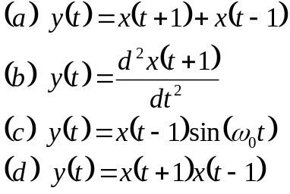

P2. Find the Laplace transform X(s) and sketch the pole-zero diagram with the ROC for the following signals x(t):

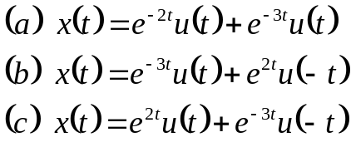

P3. Find the inverse Laplace transform of the following X(s).

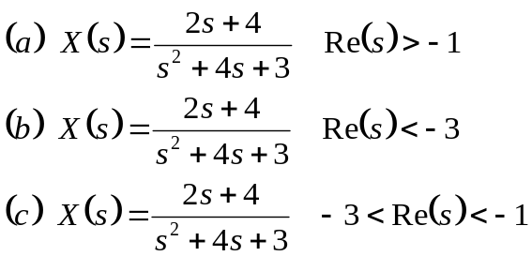

P4. In a continuous-time LTI system the input x(t) and output y(t) are related by

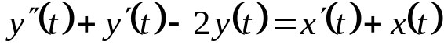

(a) Find the system function H(s).

(b) Determine the impulse response h(t) for each of the following three cases:
(i) The system is causal
(ii) The system is stable
(iii) The system is neither causal nor stable.

